**Zomato Analysis**

**Global analysis**

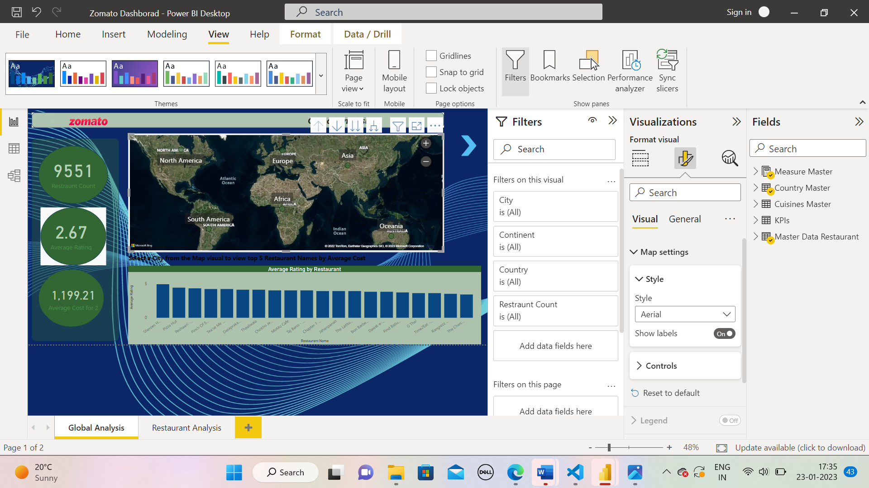

**Restaurant analysis**

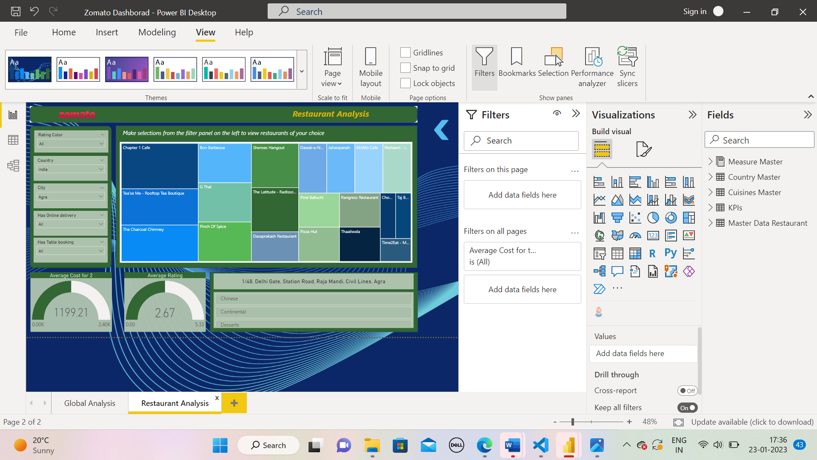

Data Modelling

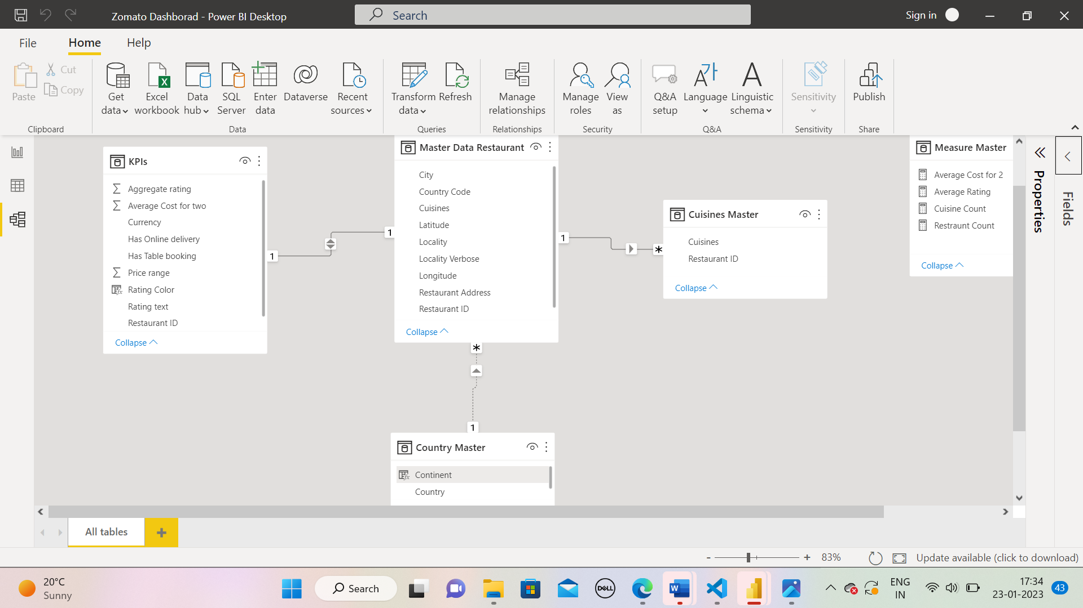

Steps to use DAX in the project:

1) Add a Rating color column in an appropriate table with the data rows in the format given below

Aggregate rating

Rating color -Above 4.5

Dark Green

4 to 4.4

Green

Solution:

Rating Color =

SWITCH (

    TRUE (),

    KPIs[Aggregate rating] >= 4.5, "Dark Green",

    AND ( KPIs[Aggregate rating] >= 4, KPIs[Aggregate rating] <= 4.4 ), "Green",

    AND ( KPIs[Aggregate rating] >= 3.5, KPIs[Aggregate rating] <= 3.9 ), "Yellow",

    AND ( KPIs[Aggregate rating] >= 2.5, KPIs[Aggregate rating] <= 3.4 ), "Orange",

    AND ( KPIs[Aggregate rating] >= 1.8, KPIs[Aggregate rating] <= 2.4 ), "Red",

    AND ( KPIs[Aggregate rating] >= 0, KPIs[Aggregate rating] <= 1.7 ), "White"

)

2) Create the following measures in the appropriate tables

a. Restaurant count

Restraunt Count = COUNT('Master Data Restaurant'[Restaurant ID])

b. Average cost

Average Cost for 2 = AVERAGE(KPIs[Average Cost for two])

c. Average rating

Average Rating = AVERAGE(KPIs[Aggregate rating])

d. Cuisine count

Cuisine Count = count('Cuisines Master'[Cuisines])

3) Create a new column in the Country Code table and name it “Continent” and create the values using the below-mentioned convention

Note: The mapping is continent - country, for example ''Africa – South Africa''

Continent = SWITCH (

    TRUE (),

    'Country Master'[Country] = "Indonesia", "Asia",

    'Country Master'[Country] = "Sri Lanka", "Asia",

    'Country Master'[Country] = "UAE", "Asia",

    'Country Master'[Country] = "India", "Asia",

    'Country Master'[Country] = "Brazil", "South America",

    'Country Master'[Country] = "Australia", "Oceania",

    'Country Master'[Country] = "Turkey", "Asia",

    'Country Master'[Country] = "South Africa", "Africa",

    'Country Master'[Country] = "United States", "North America",

    'Country Master'[Country] = "United Kingdom", "Europe",

    'Country Master'[Country] = "Phillipines", "Asia",

    'Country Master'[Country] = "Qatar", "Asia",

    'Country Master'[Country] = "Canada", "North America",

    'Country Master'[Country] = "New Zealand", "Oceania",

    'Country Master'[Country] = "Singapore", "Asia"

)